Naturopura

Naturopura is India's revolutionary agricultural platform. Our online marketplace connects farmers directly with consumers, cutting out middlemen for fair trade. With simplified transactions, access to subsidies, and the promotion of sustainable farming, we streamline the agricultural supply chain. Empowering farmers, fostering transparency, and driving India's agricultural growth.

The system includes features.

* Connects farmers, consumers, and government agencies.
* Provides access to government policies, subsidies, and loans for farmers.
* Promotes natural farming practices and biodiversity.
* Logistical system for equipment delivery.
* Review-based system for consumers to choose reliable sellers.
* Online platform for consumers to buy agricultural products.
* Direct digital linkage to processing industries, cold chains, traders, and wholesalers for farmers.

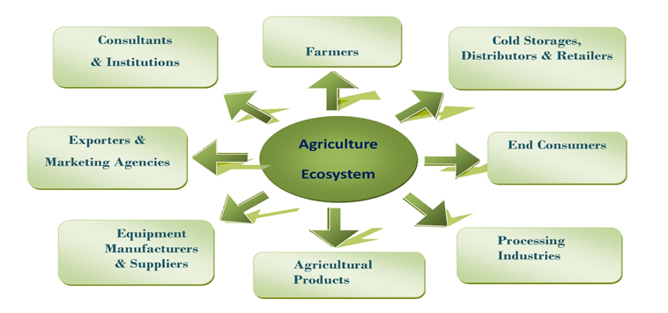

User Module:

◦ User Registration: Allows users to create an account with necessary information.

◦ User Authentication: Validates user credentials during login.

◦ User Roles and Permissions: Defines different user roles with varying access privileges.

◦ Access Control: Controls user access based on assigned roles and permissions.

◦ User Profile Management: Allows users to view and update their profile information.

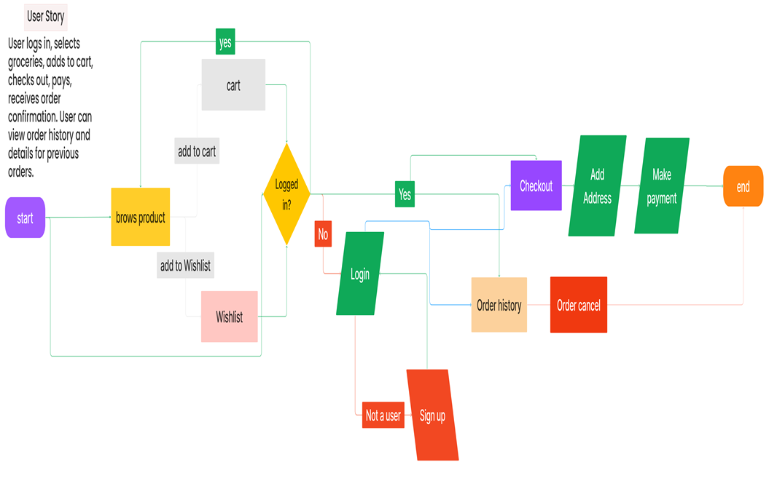

Farmer Module:

◦ Product Listing: Farmers can list their agricultural products for sale.

◦ Cold Storage Management: Farmers can arrange for cold storage facilities for perishable products.

◦ Processing Industry Opportunities: Farmers can explore opportunities in the processing industry.

◦ Consultant and Institution Connect: Farmers can seek guidance from agricultural consultants and institutions.

◦ Product Purchase: Farmers can buy agricultural products required for their farming operations.

 ◦ Online Sales and Transactions: Enables secure online transactions between farmers and buyers.

Agricultural Products Module:

◦ Product Creation: Users can create new entries for agricultural products.

◦ Edit and Update Product Listings: Users can modify existing product listings.

◦ Online Sales and Transactions: Enables online sales and transactions for agricultural products.

◦ Review-Based Model: Users can provide feedback and reviews on purchased products.

◦ User Support and Assistance: Provides user support for inquiries and assistance.

◦ Create Market Analysis Models: Allows users to create market analysis models for agricultural products.

